WORKSTREAM B — SYNTHETIC DATA DESIGN
Data Design Specification
The complete blueprint for the synthetic digital-lending dataset — the master container populated across Steps 2–10 of the build manual.

Document control
Field | Value
Document | Data Design Specification — Digital Lending Portfolio Optimization
Workstream | B — Synthetic Data Design (design only; generation is Workstream C)
Version | 1.1 — post-completion refinements (outstanding_balance, §6.9 default philosophy, prepayment) + pre-generation backtest (Appendix B)
Owner | Data Science Lead (drafts) · Senior Risk Consultant (co-signs realism logic)
Status | COMPLETE & BACKTESTED — ready for Workstream C and Gate 1
Linked artefacts | Engagement Charter (WS A, approved) · Assumptions Log (companion workbook)

Change log
Version | Date | Step | Change | Author
0.1 | 2026-06-01 | Step 1 | Specification shell and Assumptions Log created; foundational definitions imported from Charter | Data Science Lead
0.2 | 2026-06-02 | Step 2 | §3 Question → Variable Map added; variable set confirmed (no orphans); 3 design flags logged | Data Science Lead
0.3 | 2026-06-03 | Step 3 | §4 Architecture & Grain added; ER diagram; repeat-borrower logic; F1 resolved; A-014–A-017 added | Data Science Lead
0.4 | 2026-06-03 | Step 4 | §5 Variable Dictionary added (4 tables, types/ranges/distributions, derivation classes); A-018–A-020 added | Data Science Lead
0.5 | 2026-06-03 | Step 5 | §6 Risk Engine added (latent z, grade/pricing/hazard mappings, behaviour-leads-default, channel selection); relationship register R1–R12 as Gate-1 evidence; A-010 locked, A-021–A-026 added | Data Science Lead
0.6 | 2026-06-03 | Step 6 | §7 Distributions & Segment Proportions added (root/product/channel/grade mixes, ticket/tenure, pricing, default targets, value_proxy inputs); A-015 locked, A-012 updated, A-027–A-050 added | Data Science Lead
0.7 | 2026-06-03 | Step 7 | §8 Time & Panel Logic added (calendar/vintages, MOB/seasoning, panel emission & termination, DPD state machine); cure (A-007) & write-off (A-008) locked; A-051–A-055 added | Data Science Lead
0.8 | 2026-06-03 | Step 8 | §9 Outcomes & Value added (default_flag rule, loan_status transitions, value_proxy formula + waterfall, derived metrics); value_proxy (A-009) & F2 (A-012) locked; A-056–A-059 added | Data Science Lead
0.9 | 2026-06-03 | Step 9 | §10 Gate 1 Acceptance Test added (structural, data-quality, mix, default, R1–R12, vintage, value_proxy checks with MUST/SHOULD tolerances and decision rule); A-060–A-061 added | Data Science Lead
1.0 | 2026-06-03 | Step 10 | §11 Reproducibility & Conventions added; self-review vs Steps 2–9 passed; handoff to Workstream C. SPECIFICATION COMPLETE. A-062–A-064 added | Data Science Lead
1.1 | 2026-06-03 | Refine | outstanding_balance materialised (§5.3/§9); §6.9 default philosophy by product (Personal emphasised); prepayment propensity (§8.4); Appendix B parameter completeness audit (pre-generation backtest); A-065–A-068 | Data Science Lead

1. Purpose & scope of this specification
This document is the single, authoritative blueprint for the synthetic dataset that powers the Digital Lending Portfolio Optimization engagement. When finalised, it must be complete enough that a coder can generate the exact dataset with no open decisions — every table, variable, distribution, relationship, outcome rule, and quality check specified here, and every chosen number recorded in the companion Assumptions Log.
Boundary: Workstream B designs the dataset; Workstream C builds it. No data is generated within this document. B is complete only when the self-review (Step 10) passes and the Gate 1 acceptance test (Step 9) has been written in advance of generation.

2. Foundational definitions
2.1 Locked — imported from the Engagement Charter (Workstream A)
These are fixed inputs to the design. The generator must implement them exactly as stated.
Term | Definition (locked) | Source
DPD | Days Past Due, measured from the oldest unpaid installment | Charter §4
Default | A loan that has ever reached 90+ DPD — an event; once flagged, stays flagged | Charter §4
Delinquency | A loan that is currently 1+ DPD — a status; can roll forward or cure | Charter §4
DPD buckets | Current / 1–30 / 31–60 / 61–90 / 90+ days past due | Charter §4
Vintage | Loans grouped by origination month | Charter §4
Cohort observation window | 18–24 months of monthly snapshots | Charter §4

2.2 Open definitions register — flagged in the WS A review, to be locked in later steps
Term | Status | Proposed direction (not yet locked) | Lock at
Cure | LOCKED | Delinquent loan returns to Current on resumed full payment (§8.5) | Step 7
Write-off threshold | LOCKED | 180 DPD → Written-off; panel emission stops (§8.5) | Step 7
value_proxy (risk-adj. contribution) | LOCKED | Formula locked (§9.3): NII + Fee − Loss − Servicing − CAC | Step 8
EWS prediction window | LOCKED | 90-day forward window; deterioration onset 2–4 mo pre-default (§6.6) | Step 5

3. Question → Variable Map
This section is the gatekeeper for the whole dataset. Every variable must serve at least one of the five key questions, the early-warning system (EWS), or the risk engine that generates realism (§6). Anything that serves none is cut. The map is read in four parts: (3.1) what each objective must produce and the variables it needs; (3.2) how the Charter’s success metrics — especially value_proxy — reconcile to those variables; (3.3) the full coverage matrix proving no orphan fields; and (3.4) the design implications this exercise surfaces.

3.1 Analytical objective → required variables
Objective | Must produce | Required variables (raw, by name) | Charter metric served
Q1 — Segments | Risk/value segments and the attributes that define them; risk & repayment metrics per segment | region_type, income_proxy_band, employment_type, credit_quality_indicator, first_time_borrower, age, relationship_tenure_mo, product_type, origination_risk_grade, default_flag, dpd, delinquency_bucket, missed_payments_cum, paid_on_time_flag, cashflow_consistency, balance_volatility | 90+ DPD rate by segment
Q2 — Channels & economics | By-channel portfolio quality, CLV, CAC payback, full unit economics | acquisition_channel, cac, approval_tat_hrs, first_time_borrower, interest_rate_apr, ticket_size, tenure_mo, loan_status, origination_cohort, default_flag, value_proxy | CAC payback (months), CLV by segment, 90+ by channel
Q3 — Product / ticket / tenure | Growth (volume) vs. risk (default) vs. value per product × ticket × tenure cell | product_type, ticket_size, tenure_mo, interest_rate_apr, prepayment_flag, origination_date, loan_status, default_flag, value_proxy | Risk-adjusted return (RAROC / NIM-after-loss), default, volume
Q4 — Pricing / approval / tenure | Segment-tailored re-pricing, approval cut-off shifts, tenure caps; projected outcomes | origination_risk_grade, credit_quality_indicator, interest_rate_apr, tenure_mo, ticket_size, product_type, cac, default_flag, value_proxy (+ segment fields from Q1) | Risk-adj. return uplift; approval trade-off (volume per loss avoided)
Q5 — Leadership monitoring | KPIs across CRO, portfolio, risk and growth dashboard views | default_flag, dpd, delinquency_bucket, roll_rate, origination_cohort, months_on_book, value_proxy, acquisition_channel, cac, ticket_size, tenure_mo, product_type, origination_risk_grade, approval_tat_hrs, EWS flag (derived) | All: 90+ rate, RAROC, CAC payback, CLV, EWS flags & lead time
EWS — Early warning | A flag/score predicting transition to 90+ DPD within a forward window, with lead time | cashflow_consistency, balance_volatility, spending_shock_flag, nach_bounce_count, credit_utilisation, bureau_inquiry_velocity, app_engagement, partial_payment_flag, missed_payments_cum, paid_on_time_flag, dpd, months_on_book; target = default_flag / dpd transition | Share of losses pre-empted; average lead time (days)

3.2 Charter success metric → variables that compute it
Confirms the design carries every input the Charter’s finalised metrics need. value_proxy is the most-reused figure, so its inputs are itemised; some are modelling assumptions (logged), not generated columns — see flag F2.
Charter success metric | Computed from | Note
Reduction in 90+ DPD / credit loss rate | default_flag, dpd, delinquency_bucket, ticket_size (exposure) | Loss rate = defaulted exposure ÷ total exposure
Risk-adjusted return (RAROC / NIM-after-loss) | value_proxy → interest_rate_apr, fees, expected loss, cac, servicing cost | Needs LGD, fee and servicing inputs (F2)
CAC payback (months) & CLV by segment | cac, value_proxy (per-period margin), tenure_mo, loan_status | CLV aggregates value_proxy over the relationship
Share of losses pre-empted by EWS + lead time | EWS flag (derived), default_flag, dpd timing, months_on_book | Lead time = days between first flag and 90+ event
(Optional) Approval trade-off | origination_risk_grade (cut-off), default_flag, value_proxy | Cut-off simulation on approved book (F1 resolved)

3.3 Variable coverage matrix (gatekeeper)
Every variable, the objective(s) or relationship it serves, its must-/nice-to-have status (M/N), and the verdict. Result: no orphans — all fields retained. “N” fields are kept provisionally and may be dropped if they earn no lift (flag F3).
Variable | Table | Serves | M/N | Verdict
customer_id | customers | Join key (all objectives) | M | Keep (key)
region_type | customers | Q1; risk engine | M | Keep
income_proxy_band | customers | Q1; risk engine | M | Keep
employment_type | customers | Q1; risk engine | M | Keep
credit_quality_indicator | customers | Q1, Q4; risk engine | M | Keep
first_time_borrower | customers | Q1, Q2 | M | Keep
age | customers | Q1 (segment definer) | N | Keep (N)
relationship_tenure_mo | customers | Q1, Q3 | N | Keep (N)
loan_id | loans | Join key (all objectives) | M | Keep (key)
product_type | loans | Q1, Q3, Q5 | M | Keep
ticket_size | loans | Q2, Q3, Q4, Q5 | M | Keep
tenure_mo | loans | Q3, Q4, Q5 | M | Keep
interest_rate_apr | loans | Q2, Q3, Q4, Q5 | M | Keep
origination_risk_grade | loans | Q1, Q4, Q5; risk engine | M | Keep
origination_date | loans | Q2, Q5 (→ vintage) | M | Keep
approval_decision | loans | Q4, Q5 | N* | Dropped (F1)
dpd | repayments | Q1, Q5, EWS | M | Keep
delinquency_bucket | repayments | Q1, Q5 | M | Keep
paid_on_time_flag | repayments | Q1, EWS | M | Keep
partial_payment_flag | repayments | Q1, EWS | M | Keep
missed_payments_cum | repayments | Q1, EWS | M | Keep
prepayment_flag | repayments | Q3 | N | Keep (N)
cashflow_consistency | behaviour | Q1, EWS; risk engine | M | Keep
balance_volatility | behaviour | EWS; risk engine | M | Keep
spending_shock_flag | behaviour | EWS | M | Keep
nach_bounce_count | behaviour | EWS | M | Keep
credit_utilisation | behaviour | EWS (BNPL / revolving) | N | Keep (N)
bureau_inquiry_velocity | behaviour | EWS | N | Keep (N)
app_engagement | behaviour | EWS | N | Keep (N)
acquisition_channel | customers | Q2, Q5; risk engine | M | Keep
cac | customers | Q2, Q4, Q5 | M | Keep
approval_tat_hrs | loans | Q2 (onboarding proxy) | M | Keep
origination_cohort | derived | Q2, Q5 | M | Keep (derived)
months_on_book | derived | Q5, EWS | M | Keep (derived)
loan_status | loans | Q2, Q3, Q5 | M | Keep
default_flag | outcome | Q1, Q3, Q4, Q5; EWS target | M | Keep
value_proxy | outcome | Q2, Q3, Q4, Q5 | M | Keep (F2)
roll_rate | derived | Q1, Q5 | N | Keep (derived)

3.4 Design implications surfaced (to confirm in later steps)
The gatekeeping exercise raised three decisions. F1 is resolved in §4; F2 and F3 remain open.
F1 — Approval-optimisation basis (Q4). RESOLVED in §4.6: simulate cut-off shifts on the approved book using origination_risk_grade; no declined-applications table; approval_decision not generated. (Overridable — a declined layer can be added as nice-to-have.)
F2 — value_proxy inputs. Still open: expected loss (PD × LGD × EAD), fee revenue, servicing cost; confirm generated vs. assumption. Lock inputs in Step 6, formula in Step 8.
F3 — Nice-to-have retention. Still open: age, relationship_tenure_mo, prepayment_flag, credit_utilisation, bureau_inquiry_velocity, app_engagement retained provisionally. Revisit at EDA / EWS validation.

4. Table Architecture & Grain
Four tables mirror the customer journey in a two-spine hierarchy. customers sits at the top; loans hang off customers (a customer may hold several loans over time); repayments is the installment-level panel hanging off loans; and behaviour_monthly is the alt-data panel hanging off customers. The two panels are joined for the EWS by a two-hop path (§4.4).

4.1 Entity-relationship diagram
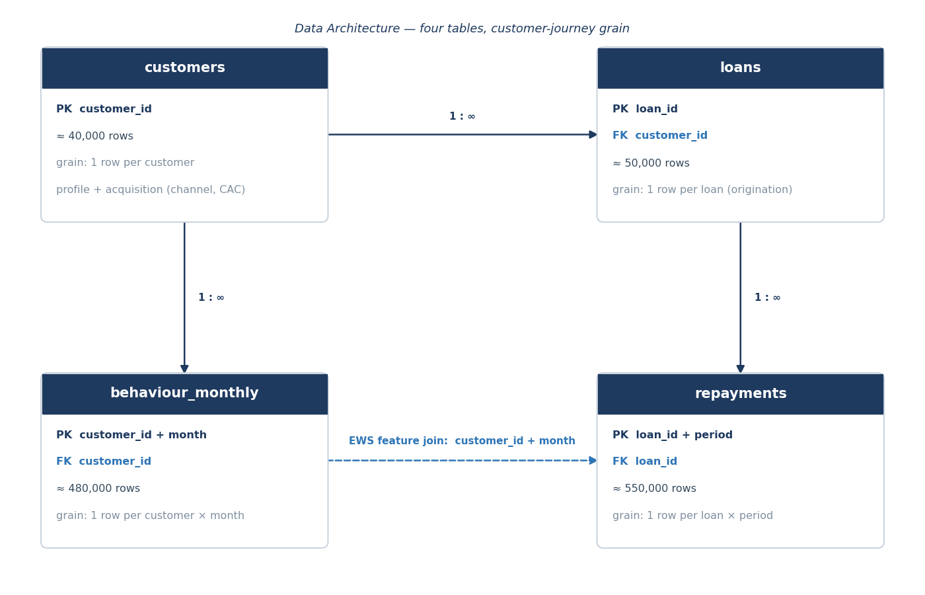

4.2 Table register
Table | Grain (one row =) | Primary key | Foreign key | Approx. rows
customers | one customer | customer_id | — | ≈ 40,000
loans | one loan (origination) | loan_id | customer_id | ≈ 50,000
repayments | one loan × scheduled period | loan_id + period | loan_id | ≈ 550,000
behaviour_monthly | one customer × month | customer_id + month | customer_id | ≈ 480,000

4.3 Variable → table home assignment
Where each variable lives, plus the structural/derived fields the grain requires (not part of the §3 analytical set, but needed by the schema).
Table | Analytical variables | Structural / derived fields
customers | region_type, income_proxy_band, employment_type, credit_quality_indicator, first_time_borrower (new-to-credit, static), age, relationship_tenure_mo, acquisition_channel, cac | —
loans | product_type, ticket_size, tenure_mo, interest_rate_apr, origination_risk_grade, origination_date, approval_tat_hrs, loan_status, default_flag, value_proxy | origination_cohort, loan_sequence (1 = first), months_on_book
repayments | dpd, delinquency_bucket, paid_on_time_flag, partial_payment_flag, missed_payments_cum, prepayment_flag | period_index, period_date, scheduled_emi, outstanding_balance, amount_paid, roll_rate
behaviour_monthly | cashflow_consistency, balance_volatility, spending_shock_flag, nach_bounce_count, credit_utilisation, bureau_inquiry_velocity, app_engagement | month (snapshot key)
Home refinements from §3: acquisition_channel and cac sit at customer grain; approval_tat_hrs at loan grain; first_time_borrower kept at customer grain as new-to-credit; loan_sequence added to identify repeats; approval_decision dropped (F1).

4.4 Join paths
- customers 1 : ∞ loans on customer_id
- loans 1 : ∞ repayments on loan_id
- customers 1 : ∞ behaviour_monthly on customer_id
- EWS feature assembly (two-hop): repayments(period_date) → loans(customer_id) → behaviour_monthly(customer_id, month = period month). Features must be assembled as-of the period with no look-ahead to prevent target leakage in the EWS.

4.5 Repeat-borrower logic
- Prevalence. ≈ 15–20% of customers hold > 1 loan. Target split ≈ 80% / 16% / 4% holding 1 / 2 / 3 loans (≈ 1.24 loans per customer), reconciling ~50,000 loans to ~40,000 customers. Exact split finalised in Step 6.
- Identification. Repeat loans are later originations, ranked within customer_id by origination_date as loan_sequence (1 = first); is-repeat = loan_sequence > 1.
- Risk inheritance. A repeat loan inherits the customer’s latent risk with mild drift. Hazard logic is specified in Step 5.
- Double-count rule. Customer-level metrics aggregate at customer grain; loan-level metrics at loan grain. The two grains are never mixed in one statistic.
- CAC attribution. Full cac is charged to the first loan (loan_sequence = 1) and zero to repeats, so per-loan unit economics do not double-count acquisition. (Feeds value_proxy — F2 / Step 8.)

4.6 Flag F1 resolved — approval-optimisation basis
Decision (locked, overridable at approval). Approval optimisation (Q4) is a retrospective cut-off simulation on the approved book, moving the origination_risk_grade (and credit_quality_indicator) cut-off and reading the realised outcomes of loans that would have been excluded. No declined-applications table is generated; approval_decision is not stored (every loan is, by construction, approved).
Rationale. A credible declined population needs a counterfactual outcome model (declined loans never repay) — heavy and speculative in a 10-day sprint. Cut-off simulation is standard, transparent, and uses only generated fields.
Override path. A declined_applications sub-table (profile + grade + decision, no repayment panel) can be added as a nice-to-have; flag at approval if desired.

5. Variable Dictionary
Every field in all four tables, with its data type, allowed values/range, the intended distribution form (exact parameters — mix %, means — are set in Step 6 / §7), must-/nice-to-have status, and derivation class. The derivation class is the most important column for the generator: it states what produces each field and, by implication, what must never be re-randomised.

5.0 Derivation classes (read this first)
- Independent (root). Sampled directly from a stated distribution; the causal roots (mostly demographics). These are the only fields drawn at random on their own.
- Risk-engine (§6). A function of the latent risk score z (and other fields), defined in Step 5. Computed, not sampled independently — re-randomising these would destroy the correlations that make the data realistic and the EWS learnable.
- Risk-engine + shock. As above, but with a time-varying monthly shock so behavioural signals move over time and lead default; still engine-controlled, never independent.
- Derived / computed. A deterministic function of other fields (no randomness); always recomputed consistently, never sampled.
- Structural. Keys and mechanical schema fields (ids, period index/date).

5.1 customers
Variable | Type | Allowed values / range | Distribution (form) | M/N | Derivation
customer_id | string | “C” + 6 digits, unique | sequential | M | Structural
region_type | categorical | Urban / Semi-urban / Rural | categorical, 3 levels (§7) | M | Independent (root)
income_proxy_band | ordinal | Low / Mid / High | ordinal, 3 levels (§7) | M | Independent (root)
employment_type | categorical | Salaried / Self-employed / Gig / Informal | categorical, 4 levels (§7) | M | Independent (root)
age | integer | 18–65 | right-skewed (mode ≈ 30) | N | Independent (root)
first_time_borrower | boolean | 0 / 1 (new-to-credit) | Bernoulli (p §7) | M | Independent (root)
credit_quality_indicator | ordinal | A / B / C / D / E (+ thin-file flag) | noisy observation of z | M | Risk-engine (§6)
acquisition_channel | categorical | Digital ads / Partner-embedded / Referral / DSA / Organic | categorical, 5 levels (§7) | M | Independent (root)
cac | float (₹) | ≥ 0; channel-specific bands | lognormal by channel (§7) | M | Derived / computed
relationship_tenure_mo | integer | 0–24 | from loan history | N | Derived / computed
true_latent_risk | float | ~ N(0,1) standardised (internal) | latent z; not delivered | — | Risk-engine (§6)
true_latent_risk is internal/validation-only — retained to verify correlations at Gate 1; excluded from the analytical dataset handed to modelling.

5.2 loans
Variable | Type | Allowed values / range | Distribution (form) | M/N | Derivation
loan_id | string | “L” + 7 digits, unique | sequential | M | Structural
customer_id | string | FK → customers | — | M | Structural
loan_sequence | integer | 1–3 | rank of origination_date within customer | M | Derived / computed
product_type | categorical | Personal / SME working capital / BNPL | categorical, 3 levels (§7) | M | Independent (root)
ticket_size | float (₹) | product-specific ranges | lognormal within product (§7) | M | Derived / computed
tenure_mo | integer | BNPL 1–6 / Personal 6–36 / SME 6–48 | discrete within product (§7) | M | Derived / computed
interest_rate_apr | float (%) | ≈ 12–48 | risk-based: f(grade, product) | M | Risk-engine (§6)
origination_risk_grade | ordinal | A–E | f(latent z) at underwriting | M | Risk-engine (§6)
origination_date | date | within observation window | vintage spread (§8) | M | Independent (root)
origination_cohort | string | YYYY-MM | from origination_date | M | Derived / computed
approval_tat_hrs | float (hrs) | ≈ 0.1–72 | lognormal by channel | M | Derived / computed
months_on_book | integer | 0 .. tenure | obs_date − origination_date | M | Derived / computed
loan_status | categorical | Active / Closed / Written-off | outcome of repayment path (§8) | M | Derived / computed
default_flag | boolean | 0 / 1 (ever 90+ DPD) | outcome of hazard path (§5/§8) | M | Risk-engine (§6)
value_proxy | float (₹) | may be negative | computed formula (§8, F2) | M | Derived / computed

5.3 repayments
Variable | Type | Allowed values / range | Distribution (form) | M/N | Derivation
loan_id | string | FK → loans | — | M | Structural
period_index | integer | 1 .. tenure_mo | sequential per loan | M | Structural
period_date | date | origination_date + n months | deterministic | M | Derived / computed
scheduled_emi | float (₹) | > 0 | amortisation of ticket, APR, tenure | M | Derived / computed
outstanding_balance | float (₹) | ≥ 0 | opening principal from amortisation, adjusted for actual payments; basis for NII / EAD / NIM | M | Derived / computed
amount_paid | float (₹) | 0 .. ≥ EMI | f(payment behaviour, §5) | M | Risk-engine (§6)
dpd | integer | 0 .. write-off threshold | f(payment path, §5) | M | Risk-engine (§6)
delinquency_bucket | ordinal | Current / 1–30 / 31–60 / 61–90 / 90+ | from dpd | M | Derived / computed
paid_on_time_flag | boolean | 0 / 1 | amount_paid ≥ EMI by due date | M | Derived / computed
partial_payment_flag | boolean | 0 / 1 | 0 < amount_paid < EMI | M | Derived / computed
missed_payments_cum | integer | 0 .. | cumulative misses to date | M | Derived / computed
prepayment_flag | boolean | 0 / 1 | early full settlement; f(behaviour) | N | Risk-engine (§6)
roll_rate | metric | bucket → bucket transition rate | analysis-time; not a stored column | N | Derived / computed

5.4 behaviour_monthly
Variable | Type | Allowed values / range | Distribution (form) | M/N | Derivation
customer_id | string | FK → customers | — | M | Structural
month | date | YYYY-MM within obs. window | monthly snapshot | M | Structural
cashflow_consistency | float | 0–1 | f(z) + shock; falls pre-default | M | Risk-engine + shock
balance_volatility | float | ≥ 0 (normalised) | f(z) + shock; rises pre-default | M | Risk-engine + shock
spending_shock_flag | boolean | 0 / 1 | Bernoulli; prob rises pre-default | M | Risk-engine + shock
nach_bounce_count | integer | 0–5 (rolling 3m) | Poisson; rate rises pre-default | M | Risk-engine + shock
credit_utilisation | float (%) | 0–100+ (BNPL / revolving) | f(z); creeps up pre-default | N | Risk-engine + shock
bureau_inquiry_velocity | integer | 0–10 (last 90d) | Poisson; rises with stress | N | Risk-engine + shock
app_engagement | float | sessions/mo ≥ 0 | f(z); may drop pre-default | N | Risk-engine + shock

6. Risk Engine & Relationship Design
This is the realism core. Rather than generating fields independently and bolting on correlations, the dataset is built causally: everything flows from a single per-customer latent creditworthiness score z plus a per-customer stress process s(t), so the relationships in the brief’s expected-relationship table fall out by construction. This section gives the form of every relationship and its signed direction and rough strength; exact parameter values (weights, cut-points, hazard constants) are calibrated in Step 6 / §7.

6.1 Generative DAG
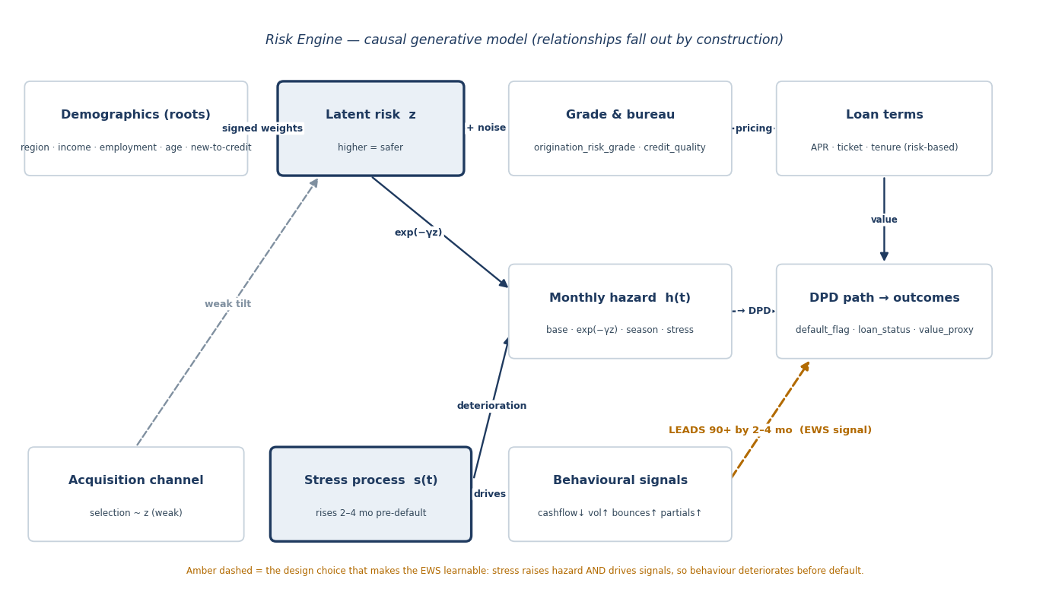

6.2 Layer 1 — latent creditworthiness z
Each customer gets z = (signed-weighted sum of profile features) + noise, standardised to ≈ N(0,1), with higher z = safer. Signs are set so a weaker profile pulls z down. Noise is calibrated so profile explains roughly 40–50% of z’s variance (§7) — enough signal to separate risk, enough randomness to be realistic.
Feature | Direction (level → effect on z) | Weight (sign · strength)
income_proxy_band | High → safer; Low → riskier | + Strong
employment_type | Salaried → safer; Gig / Informal → riskier | + / − Strong
region_type | Urban → safer; Rural → riskier | + Moderate
first_time_borrower (new-to-credit) | new-to-credit → riskier (thin file) | − Moderate
age | prime (30–50) → slightly safer (non-linear) | + Weak
noise ε | idiosyncratic; not explained by profile | calibrated (§7)
Indicative standardised magnitudes (calibrated §7): Strong ≈ 0.30–0.40, Moderate ≈ 0.15–0.25, Weak ≈ 0.05–0.15.

6.3 Layer 2 — observed credit signals
Both credit signals are noisy observations of z, not independent draws (A-020). credit_quality_indicator = discretise(z + bureau noise) and origination_risk_grade = discretise(z + underwriting noise) into bands A–E, with cut-points chosen to hit the grade mix (§7). Independent noise terms make the two grades correlated but not identical; the thin-file flag (new-to-credit) widens the bureau noise. Higher z → grade A.

6.4 Layer 3 — loan terms (risk-based)
interest_rate_apr = product base rate + grade risk-premium + small noise, so a worse grade carries a higher APR. “Tighter terms” also applies mildly to size and length: a worse grade modestly lowers the offered ticket cap and shortens the maximum tenure. This honours the brief’s higher risk → tighter terms / higher pricing. Pricing curve and premiums are set in §7.

6.5 Layer 4 — default hazard & DPD path
Each loan carries a monthly default hazard:
h(t) = baseline(product, tenure) × exp(−γ·z) × seasoning(t) × macro(cohort, t) × stress_mult(s(t))
- exp(−γ·z): lower z → higher hazard. γ is calibrated (§7) so grades separate materially and the blended 90+ rate hits target.
- seasoning(t): a product-specific hump (BNPL front-loaded, Personal mid, SME later).
- macro(cohort, t): a small calendar factor so vintages differ modestly — honours “newer cohorts may behave differently.”
- stress_mult(s(t)): rises when the stress process (Layer 5) switches on.
DPD path: each period draws a payment outcome — full / partial / miss — with miss-probability rising in current hazard and stress. A miss rolls DPD forward (≈ +30); a full payment cures toward 0 (per the cure rule, Step 7); a partial payment holds or slowly worsens. Reaching 90+ sets default_flag = 1 (sticky, per Charter). At the write-off threshold (proposed 180 DPD, Step 8) loan_status becomes Written-off and the panel stops. delinquency_bucket, missed_payments_cum and roll rates all emerge from this path — they are not generated independently.

6.6 Layer 5 — behaviour leads default (the critical design choice)
This is the single most important mechanism in the dataset. Each customer has a latent stress process s(t) ≥ 0, near zero in normal times. For a loan that will default, s(t) begins ramping up 2–4 months before the 90+ event (the lead window). The behavioural signals are functions of s(t):
- cashflow_consistency = base(z) − a·s(t) + shock (falls)
- balance_volatility = base(z) + b·s(t) + shock (rises)
- spending_shock_flag ~ Bernoulli(p₀ + c·s(t)) ; nach_bounce_count ~ Poisson(λ₀ + d·s(t))
- credit_utilisation and bureau_inquiry_velocity rise with s(t); app_engagement falls.
Because s(t) both raises the hazard and drives the signals, deterioration is observable before default — which is exactly what gives the EWS (Workstream F) real lead time. Critical realism guard: a fraction of stress episodes resolve (cure) without ever reaching 90+, so the signals produce realistic false positives and the EWS is strong-but-imperfect rather than a giveaway. If this mechanism is wrong, the EWS has nothing to learn.
Locked (A-010): EWS target = transition to 90+ DPD within a 90-day forward window; behavioural deterioration onset 2–4 months pre-default.

6.7 Layer 6 — channel selection vs z
acquisition_channel is assigned conditioned on z: aggressive scale channels (Digital ads, DSA) are slightly more likely for lower-z customers, while Organic and Referral skew higher-z. The tilt is weak — by-channel default differences are mostly a composition effect, not a strong independent driver. cac and approval_tat_hrs are channel attributes (paid channels: fast TAT, higher CAC; organic: cheapest). This honours “faster/cheaper growth may carry higher risk.” Channel mix and CAC/TAT values are set in §7. (An optional small direct channel effect on hazard is a nice-to-have.)

6.8 Relationship register (Gate 1 evidence)
Each designed relationship as a one-liner with direction and rough strength, tagged to the brief’s expected-relationship table. This is the checklist Gate 1 verifies in the generated data — every row below must be demonstrably present and in the stated direction.
ID | Designed relationship (direction) | Strength | Brief expectation satisfied
R1 | Weaker profile (low income, informal/gig, rural, new-to-credit) → lower z → higher default | Strong | Customer Profile: weaker profiles → higher risk
R2 | Lower z → worse origination_risk_grade and bureau band (noisy) | Strong | Customer Profile (grading mechanism)
R3 | Worse grade → higher APR and modestly tighter ticket/tenure | Strong / Moderate | Loan & Product: higher risk → tighter terms / higher pricing
R4 | Lower z → higher monthly hazard → higher 90+ rate by grade | Strong | Customer Profile / Outcomes
R5 | Behavioural deterioration begins 2–4 months BEFORE the 90+ event | Strong (designed) | Repayment Behaviour: deteriorating behaviour precedes default
R6 | Higher balance_volatility / lower cashflow_consistency → higher delinquency | Strong | Behavioural Signals: higher volatility → higher delinquency
R7 | Rising partial payments and missed_payments_cum precede default | Moderate–Strong | Repayment Behaviour
R8 | Aggressive scale channels (Digital ads, DSA) skew slightly lower z → modestly higher default | Weak (composition) | Acquisition: faster/cheaper growth may carry higher risk
R9 | Channel drives cac and approval_tat_hrs (paid: fast TAT, high CAC; organic: cheapest) | Descriptive | Acquisition
R10 | Calendar/macro factor makes some vintages default modestly higher | Weak–Moderate | Time Dimension: newer cohorts may behave differently
R11 | High-z, adequately priced segments earn higher value_proxy; high-risk segments underperform | Strong (by construction) | Outcomes: certain segments outperform on risk-adjusted basis
R12 | A fraction of stress episodes cure without default (false positives) | Moderate | Repayment Behaviour (realism guard for the EWS)

6.9 Default philosophy by product
The three products differ not only in default rate but in default character: what triggers it, when it peaks, how it rolls and cures, and how severe it is. The generator must shape each product’s hazard baseline, seasoning and cure profile to these archetypes — not treat Personal as a bland midpoint.
Product | What drives default | Timing (seasoning) | Roll / cure character | Severity
BNPL | Thin-file + impulse / over-extension on small obligations | Front-loaded (MOB 1–3); early / first-cycle misses | Fast roll to write-off (short tenor); little cure window | Low (LGD ≈40%)
Personal | Income / employment shock and over-leverage — borrower financial stress | Mid-life hump (MOB ≈4–12, peak ~6–9); declines as good payers self-select | Gradual roll; meaningful cure in 1–30 / 31–60; cure falls sharply at 61–90+ | Moderate (LGD ≈65%)
SME working capital | Business cash-flow / cyclicality and receivable shocks | Later, longer-developing (MOB ≈6–18) | Irregular; lumpy partials; cure if receivables clear, else deep write-off | High (LGD ≈75%)
Personal loans — the core archetype. Personal is the cleanest expression of the engine’s latent-risk + stress mechanism (§6.2, §6.6): z sets baseline propensity and the per-customer stress process s(t) — the 2–4 month deterioration — is the primary default trigger, reflecting an income or employment shock on an over-leveraged borrower. Default is therefore gradual and observable, which is exactly why the early-warning system earns most of its value on this product. A small early-default tail exists for the weakest grades, but the mass of Personal defaults is mid-life (MOB ~6–9), with real cure opportunity in the early buckets. The generator must reproduce this shape — not a flat hazard — so segmentation, the EWS and pricing all behave realistically for the book’s largest product.

7. Distributions & Segment Proportions
This section turns the engine’s forms (§6) into concrete numbers. Two kinds of value appear here: fixed inputs the generator samples directly (root mixes, ticket/tenure ranges, channel attributes) and target outputs the generator must reproduce (grade mix, default rates). Internal constants — the z weights’ exact betas, grade cut-points, the hazard slope γ and baselines — are not fixed numbers; they are tuned in Workstream C until the targets hold within tolerance (§7.10). Every value below is recorded in the Assumptions Log. All amounts are in INR (₹); full conventions are in §11.

7.1 Volumes and repeat split
Quantity | Value | Rationale
customers | ≈ 40,000 | Customer base supporting ~50k loans
loans | ≈ 50,000 | Adequate for grade × product × channel cell analysis
repayments (panel) | ≈ 550,000 | ~50k loans × ~11 active periods
behaviour_monthly (panel) | ≈ 480,000 | ~40k customers × ~12 active months
repeat-borrower split | 80% / 16% / 4% hold 1 / 2 / 3 loans (≈ 1.24 loans/customer) | Locks A-015; honours brief's repeat borrowers

7.2 Customer root distributions (inputs to z)
Attribute | Distribution / mix | Rationale
region_type | Urban 45% / Semi-urban 40% / Rural 15% | Brief's urban + semi-urban focus, some rural reach
income_proxy_band | Low 35% / Mid 45% / High 20% | Mass-market skew typical of digital lending
employment_type | Salaried 45% / Self-employed 25% / Gig 18% / Informal 12% | Mix of formal and informal; rising gig share
age | 18–65; right-skewed, median ≈ 32 | Young, digitally-native borrower base
first_time_borrower (new-to-credit) | ≈ 35% | Brief: first-time borrowers & underbanked segments

7.3 Product mix, ticket size and tenure
Product | Share | Ticket size (₹) | Tenure (months) | Rationale
BNPL | 35% | 2,000 – 50,000 (med ≈ 12,000) | 1–6 (mode 3) | Small-ticket, short, high-frequency
Personal | 45% | 30,000 – 500,000 (med ≈ 120,000) | 6–36 (mode 18) | Core unsecured product
SME working capital | 20% | 200,000 – 5,000,000 (med ≈ 800,000) | 6–48 (mode 24) | Large-ticket, longer, lower-frequency

7.4 Grade mix
Origination-grade mix of the approved book. z → grade cut-points (§6.3) are set during generation to reproduce this distribution.
Origination grade → | A | B | C | D | E
Share of book | 15% | 30% | 30% | 18% | 7%

7.5 Risk-based pricing (APR)
Product | APR range | Grade premium | Rationale
BNPL | 24–48% | ≈ +3pp per grade step worse | Thin-file, short tenure, higher unit cost
Personal | 16–36% | ≈ +4pp per grade step worse | Core risk-based pricing
SME working capital | 14–28% | ≈ +3pp per grade step worse | Larger, modestly finer pricing

7.6 Channel mix, CAC, TAT and z-tilt
Channel | Share | CAC (₹) | Approval TAT | z-tilt | Rationale
Digital ads | 35% | 1,200 | 2–6 h | −0.10 | Scaled paid acquisition; marginally weaker
Partner-embedded | 25% | 600 | 1–4 h | 0.00 | Embedded checkout; neutral quality
Referral | 15% | 300 | 6–24 h | +0.10 | Referred customers tend to be better
DSA / agent | 15% | 1,000 | 24–72 h | −0.15 | Agent-sourced; weaker, slower, commission
Organic | 10% | 150 | 4–24 h | +0.10 | Self-select; cheapest, better quality
z-tilt is in z standard-deviation units — a weak shift in the mean latent risk of each channel’s intake (§6.7), so by-channel default differences are mostly composition.

7.7 Default targets (headline calibration)
Blended 90+ default target ≈ 7.5% (acceptable range 6–9%). Two gradients below are jointly calibrated and both must hold (Gate 1): by product (frequency × severity) and by grade.
By product
Product | Target 90+ default | LGD (severity) | Rationale
BNPL | ≈ 10% | ≈ 40% | Higher frequency, lower severity (small tickets)
Personal | ≈ 7% | ≈ 65% | Mid frequency and severity
SME working capital | ≈ 5% | ≈ 75% | Lower frequency, higher severity (large, unsecured)
By origination grade
Grade → | A | B | C | D | E | Blended
Target 90+ default | 1.5% | 3.5% | 7% | 14% | 26% | ≈ 7.7%

7.8 value_proxy inputs (resolves the input side of F2)
The components value_proxy needs (§3.2). These are pinned here; the assembling formula is locked in Step 8.
Input | Assumption | Rationale
LGD by product | BNPL 40% / Personal 65% / SME 75% | Unsecured loss severity differs by product
Fee revenue | ≈ 1–2% of ticket at origination (BNPL largely merchant-subsidised) | Processing / origination fees
Servicing cost | ≈ ₹80 per active loan-month | Collections and servicing opex
Cost of funds | ≈ 11% annual | Funding cost for NIM-after-loss / RAROC

7.9 Behavioural baselines and stress response (indicative)
Normal-state baselines and the direction/scale under stress (§6.6). Exact coefficients are tuned in C; ≈ 35% of elevated-stress episodes cure without reaching 90+ (false-positive realism for the EWS).
Signal | Normal baseline | Under stress
cashflow_consistency | ≈ 0.75 | falls toward 0.3–0.5
balance_volatility | ≈ 0.20 | rises toward 0.5–0.8
spending_shock_flag | ≈ 3% of months | 30–50% of stressed months
nach_bounce_count | ≈ 0 (rare) | 1–3 in stressed months
credit_utilisation | ≈ 35% | climbs toward 80–100%
bureau_inquiry_velocity | 0–1 / 90d | 2–4 / 90d
app_engagement | normal | drops

7.10 Time / vintage spread and calibration note
- Vintage spread. Originations are spread across an 18–24 month window with mild growth — newer cohorts ≈ 10–15% larger — reflecting the rapid-growth context. A small macro factor (±1–2pp on hazard) differentiates vintages.
- Calibration discipline. The exact z weights, grade cut-points, hazard slope γ, baselines and seasoning are not fixed here; they are tuned in Workstream C until the grade mix (§7.4) and the by-product and by-grade default targets (§7.7) all hold within tolerance. The targets are the defensible numbers; the internal constants are whatever reproduces them — this is exactly what Gate 1 checks.

8. Time & Panel Logic
How the dataset moves through time: the calendar frame and vintages, months-on-book and seasoning, the rules by which the repayment panel is emitted and terminated, and the DPD roll / cure / write-off dynamics. This section locks two open definitions — cure (A-007) and the write-off threshold (A-008) — because the panel-termination logic cannot be specified without them. The financial treatment of written-off loans (recovery, loss) is completed in Step 8 (§9).

8.1 Calendar frame & observation window
- Window. A 24-month calendar (months M1–M24), within the Charter’s 18–24-month range.
- Snapshot (“as-of”) date. The dataset is cut at the end of M24. Every “current” field — delinquency_bucket, months_on_book, loan_status — is measured as of this date.
- Vintage. Origination month (Charter). 24 monthly vintages, V1…V24.
- Right-censoring. Long-tenor loans (Personal up to 36, SME up to 48) originated early are still active at the snapshot; their performance is observed only up to M24 and is censored thereafter — realistic and expected.

8.2 Origination spread & cohort drift
Originations are spread across all 24 vintages with mild growth (newer cohorts ≈ 10–15% larger, per §7), reflecting the rapid-growth context. Product, channel and grade mixes are broadly stable across vintages, with a deliberate small drift in the most recent cohorts toward slightly higher-risk intake, plus the macro hazard factor (§7.10). Together these make newer vintages show modestly worse early delinquency — the mechanism behind “newer cohorts may behave differently” (R10). The newest 1–2 vintages are intentionally immature (little performance history); this is expected, not an error.

8.3 Months-on-book (MOB) & seasoning
- MOB. Months since origination, measured to the snapshot for active loans or to termination for closed loans. Performance (cumulative default, delinquency) is indexed by MOB for vintage-curve analysis.
- Seasoning. The hazard hump (§6.5) peaks at product-specific MOB: BNPL ≈ MOB 1–3 (front-loaded), Personal ≈ MOB 4–12, SME ≈ MOB 6–18, then declines.

8.4 Panel emission & termination (repayments)
Each loan emits one repayment row per scheduled monthly period (period_index 1…tenure_mo; period_date = origination_date + k months). Emission continues until the loan terminates in one of four ways:
Termination | Trigger | loan_status | Panel rows emitted
Closed (matured) | Reaches scheduled maturity, fully paid | Closed | = tenure_mo
Closed (prepaid) | Early full settlement (prepayment_flag) | Closed | to prepay period
Written-off | DPD reaches 180 (§8.5) | Written-off | to write-off period
Active (censored) | Still within tenure at the snapshot | Active | to M24 (snapshot)
Rows per loan = min(tenure, months-to-termination, months-to-snapshot). Summed across ~50k loans this yields the ≈ 550,000-row panel (§7.1).
Prepayment propensity. Among performing loans, lifetime prepayment ≈ Personal 15% / SME 10% / BNPL 2% (short tenor), skewing higher for grades A–B (more refinancing options). Prepayment closes a loan early (loan_status = Closed), truncating the panel and reducing realised interest in value_proxy.

8.5 Delinquency dynamics: roll, cure, write-off
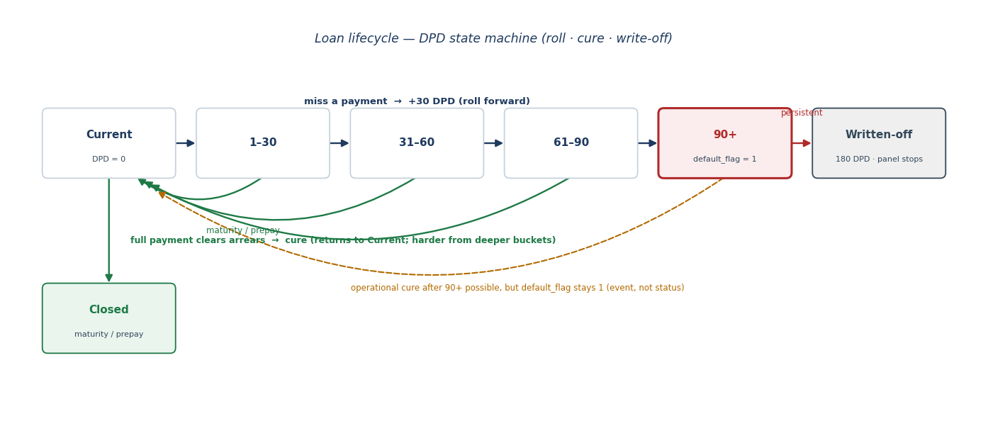
- Roll forward. A missed payment rolls DPD forward (≈ +30) into the next bucket; a partial payment holds or slowly worsens the bucket.
- Cure (locks A-007). A delinquent loan returns to Current when the borrower resumes full payment and clears arrears. Cure probability decreases with bucket depth (easier from 1–30 than from 61–90).
- Default is an event, not a status. Once a loan touches 90+, default_flag = 1 permanently (Charter). The loan may still cure operationally afterwards, but default_flag stays 1 — cure affects delinquency status and roll rates, never the default event.
- Write-off (locks A-008). At 180 DPD (six missed cycles — a standard charge-off point) the loan becomes Written-off, panel emission stops, and the exposure crystallises as loss (recovery / value treatment in §9).
- Roll/cure rates are not generated — they emerge from these transitions and are computed as an analysis-time bucket-to-bucket matrix.

8.6 Vintage-curve ageing expectations (Gate 1)
How the curves must behave, stated so Gate 1 can verify them in the generated data:
- Cumulative default by MOB is non-decreasing within a vintage (default is sticky).
- Older vintages are more matured — higher cumulative default at the snapshot than younger vintages — while at equal MOB vintages are broadly comparable, except for the deliberate newer-cohort drift (newer modestly worse at equal MOB).
- Marginal default by MOB (hazard) shows the product seasoning hump, then declines.
- BNPL curves mature fast and flatten early (short tenor); SME curves develop slowly over a longer horizon.
- Snapshot alignment: behaviour_monthly months and repayment period_dates align on calendar month for the EWS two-hop join, with no data beyond M24 (no look-ahead).

9. Outcomes & Value Calculation
The financial outcomes of the dataset, encoded as exact rules so they compute one way only. This section locks the last open item in the specification — the value_proxy formula (flag F2). default_flag and loan_status follow the Charter and §8; value_proxy assembles the inputs pinned in §7.8.

9.1 default_flag (the default event)
- Rule. default_flag = 1 if the loan’s DPD ever reaches ≥ 90 at any period; otherwise 0. Loan-level, sticky — once set, it stays set (Charter A-002).
- Not reversed by cure. A loan that touches 90+ and later cures keeps default_flag = 1. Default is an event; cure changes only the current delinquency status (§8.5).

9.2 loan_status (as-of-snapshot)
Measured at the M24 snapshot, with strict precedence Written-off > Closed > Active:
loan_status | Condition (as of snapshot)
Written-off | DPD reached 180 at or before snapshot (panel stopped)
Closed | Reached scheduled maturity fully paid, or prepaid, before snapshot — and not written off
Active | Within tenure and not yet terminated at snapshot (may be Current or delinquent)
Independent of default_flag. The two are different dimensions: a loan can be default_flag = 1 with loan_status = Closed (hit 90+, cured, matured), Active (currently impaired), or Written-off. Analysts must not treat “defaulted” and “written-off” as synonyms.

9.3 value_proxy formula (resolves F2)
Per-loan lifetime risk-adjusted contribution, in ₹. Computed once in a single controlled function so every downstream number reconciles (one number, one source).
value_proxy = NII + Fee − Loss − Servicing − CAC
Term | Definition | Inputs / source
NII (net interest income) | Σ over performing periods of (APR − CoF)/12 × outstanding_balanceₜ | interest_rate_apr; cost of funds ≈11% (A-050); outstanding_balance (§5.3)
Fee | fee_rate(product) × ticket_size, once at origination | fee rate ≈1–2% (A-048); BNPL largely merchant-subsidised
Loss | Written-off: LGD × outstanding_balance@write-off | currently 90+: LGD × outstanding_balance | else 0 | LGD by product (A-044); outstanding_balance (§5.3)
Servicing | servicing_monthly × active_months | ≈ ₹80 / active loan-month (A-049)
CAC | cac if loan_sequence = 1, else 0 | cac (A-038); first-loan attribution (A-016)
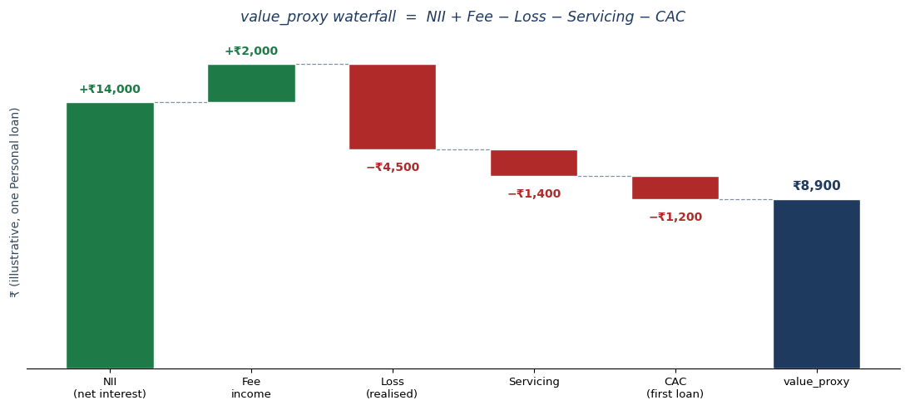

9.4 Derived value metrics (analysis-time)
- CLV (customer). Σ value_proxy over the customer’s loans (customer grain; CAC counted once via first-loan attribution).
- CAC payback (months). cac ÷ monthly contribution, where monthly contribution = (NII + Fee − Servicing) ÷ active_months.
- Risk-adjusted return. NIM-after-loss = (Σ NII − Σ Loss) ÷ Σ average outstanding, annualised, by segment/portfolio. Economic capital is out of scope (Charter), so RAROC is proxied by NIM-after-loss / return-on-assets rather than a capital-based denominator.

9.5 Loss treatment note
Loss in value_proxy is realised for written-off loans (LGD × exposure at write-off) and a simple provision for loans still 90+ at the snapshot (LGD × current outstanding); cured and never-defaulted loans carry zero loss. This is a pragmatic per-loan loss measure, not IFRS 9 ECL or regulatory provisioning, which are explicitly out of scope (Charter). A separate forward-looking expected loss (PD × LGD × EAD, using the by-grade PD targets in §7.7) is used only for pricing analysis in Workstream G — never written into value_proxy.

10. Gate 1 Acceptance Test
Written before any data exists, so Workstream C builds to the test rather than being judged after it. Each check has an explicit criterion and tolerance. MUST checks (navy) are gating; SHOULD checks (amber) are realism refinements that may be waived with a logged rationale. The ✓ column is left blank for the reviewer.

10.1 Structural integrity
ID | Check | Acceptance criterion (tolerance) | Test method | ✓
S1 | Key uniqueness | customer_id, loan_id, (loan_id+period), (customer_id+month) 100% unique | group-by count = 1 | ☐
S2 | Referential integrity | Every foreign key resolves to a parent row; 0 orphans | anti-join count = 0 | ☐
S3 | Grain | No duplicate grain key in any table | duplicate check | ☐
S4 | Repayment panel completeness | Contiguous period_index 1..N per loan, N = min(tenure, termination, snapshot); no gaps | per-loan sequence check | ☐
S5 | Behaviour panel completeness | One row per customer active-month in window; no gaps | sequence check | ☐
S6 | Counts & repeat split | ≈50k loans / ≈40k customers; repeat split 80/16/4 (±3pp) | counts vs targets | ☐
S7 | Panel volumes | repayments ≈ 550k, behaviour ≈ 480k (±10%) | row counts | ☐

10.2 Data quality
ID | Check | Acceptance criterion (tolerance) | Test method | ✓
Q1 | Must-have non-null | All M-flagged fields (§5) 100% non-null | null count = 0 | ☐
Q2 | Value ranges | Every field within §5 range (age 18–65, APR 12–48%, dpd ≥ 0, ticket/tenure within product bands) | range check | ☐
Q3 | Categorical domains | region/employment/product/channel/grade/bucket take only declared values | set membership | ☐
Q4 | Types & units | Valid dates; currency ≥ 0 where required; correct dtypes | dtype/validity check | ☐
Q5 | Derived consistency | delinquency_bucket ↔ dpd; MOB = snapshot − origination; cohort = month(orig); scheduled_emi & outstanding_balance reconcile to amortisation + payments | recompute & compare | ☐

10.3 Distribution & mix conformance
ID | Check | Acceptance criterion (tolerance) | Test method | ✓
D1 | Product mix | Personal 45 / BNPL 35 / SME 20 (±3pp) | share vs target | ☐
D2 | Channel mix | Digital 35 / Partner 25 / Referral 15 / DSA 15 / Organic 10 (±3pp) | share vs target | ☐
D3 | Grade mix | A15 / B30 / C30 / D18 / E7 (±3pp) | share vs target | ☐
D4 | Root mixes | region / income / employment within ±3pp of §7.2 | share vs target | ☐
D5 | New-to-credit share | ≈ 35% (±3pp) | share vs target | ☐
D6 | Ticket / tenure | Within product ranges; medians within ±20% of §7.3 | range & median | ☐

10.4 Default & risk targets
ID | Check | Acceptance criterion (tolerance) | Test method | ✓
DR1 | Blended 90+ default | Within 6–9% (target ≈ 7.5%) | portfolio default rate | ☐
DR2 | By-product default | BNPL ≈10 / Personal ≈7 / SME ≈5 (±1.5pp); ordering BNPL > Personal > SME | by-product rate | ☐
DR3 | By-grade gradient | Strictly increasing A→E; near 1.5/3.5/7/14/26% (±20% rel.) | by-grade rate; monotonic | ☐
DR4 | Severity ordering | Loss severity SME > Personal > BNPL (LGD reflected) | mean loss-given-default | ☐

10.5 Relationship conformance (R1–R12)
R4 is verified by DR3 (by-grade gradient). Each row restates a §6.8 relationship as a measurable test.
ID | Check | Acceptance criterion (tolerance) | Test method | ✓
R1 | Weaker profile → higher default | Default rises: Low income > High; Informal/Gig > Salaried; Rural > Urban; new-to-credit > not | group default rates; direction | ☐
R2 | z → grade / bureau | Worse grade & bureau band associate with higher default (signs as designed) | correlation / group rates | ☐
R3 | Grade → pricing / terms | Mean APR increases A→E (monotonic); ticket & max tenure modestly lower for worse grades | by-grade APR & terms | ☐
R5 | Behaviour LEADS default | Among defaulters, deterioration onset precedes 90+ by 2–4 mo; median lead ≥ 60 days | event-time alignment | ☐
R6 | Volatility → delinquency | Defaulters show lower cashflow_consistency / higher balance_volatility pre-default; single-feature AUC > 0.6 | group means; AUC | ☐
R7 | Payment signals precede default | Rising partial payments & missed_payments_cum before 90+ | event-time trend | ☐
R8 | Channel risk composition | Digital / DSA modestly higher default than Organic / Referral | by-channel default | ☐
R9 | Channel CAC / TAT | Ordering matches §7.6 (Organic cheapest; DSA slowest) | by-channel CAC / TAT | ☐
R10 | Vintage differences | Newer cohorts modestly higher early delinquency at equal MOB | cohort-by-MOB | ☐
R11 | Value separation | High-z / grade-A segments earn higher value_proxy; high-risk lower / negative | by-segment value_proxy | ☐
R12 | EWS realism | 30–40% of elevated-stress episodes cure without 90+; single-feature AUC strong but < 0.95 | cure fraction; AUC | ☐

10.6 Vintage & panel dynamics
ID | Check | Acceptance criterion (tolerance) | Test method | ✓
V1 | Cumulative default monotone | Non-decreasing in MOB within a vintage (default sticky) | cumulative curve | ☐
V2 | Older vintages more matured | Higher cumulative default at snapshot for older vintages | vintage curves | ☐
V3 | Seasoning hump | Hazard rises then declines; product-specific peak MOB | marginal default by MOB | ☐
V4 | Write-off rule | Write-off only at dpd ≥ 180; no rows emitted after write-off | status & panel check | ☐
V5 | Cure observed | Some delinquent loans return to Current; roll/cure matrix sensible | transition matrix | ☐
V6 | default_flag integrity | Sticky (never 1→0); non-trivial cross-tab with loan_status | flag checks | ☐
V7 | Prepayment rate | Lifetime prepayment near targets (Personal ≈15%, SME ≈10%, BNPL ≈2%); BNPL near-zero | by-product prepay rate | ☐

10.7 value_proxy sanity
ID | Check | Acceptance criterion (tolerance) | Test method | ✓
VP1 | value_proxy computes | No nulls; equals component sum (single source reconciles) | recompute & compare | ☐
VP2 | Sign distribution | Most performers positive; many write-offs negative; not single-signed | distribution | ☐
VP3 | Value–risk ordering | Grade-A mean value_proxy > grade-E (ties R11) | by-grade mean | ☐
VP4 | Derived metrics finite | CLV, CAC payback, NIM-after-loss compute and are sensible | metric checks | ☐

10.8 Gate decision rule
- Decision. PASS if and only if every MUST check passes. Any MUST failure → fix the generator and re-run; do not proceed to EDA. SHOULD failures may be waived with a rationale logged in the Assumptions Log.
- Tolerances (summary). Mixes ±3pp; blended default 6–9%; by-product ±1.5pp; by-grade ±20% relative and strictly monotonic; relationships must hold directionally and be statistically clear; EWS median lead ≥ 60 days.
- Sign-off. PMO logs the Gate 1 result. On PASS, the dataset is frozen — the seed is recorded (§11) — and handed to Exploratory Analysis (Workstream D).

11. Reproducibility & Conventions
The final layer: how the dataset is made deterministic and consistent, a self-review confirming the specification is complete, and the formal handoff to Workstream C — whose only job is to implement this document and pass Gate 1.

11.1 Reproducibility
- Master seed. A single fixed seed (20260603). Every stochastic draw derives from it via one seeded RNG, with per-table and per-customer sub-streams derived deterministically so partial regeneration reproduces identical values.
- Fixed generation order. roots → latent z → grade & bureau → loan terms → channel selection → origination / time & panel → behavioural signals → DPD & outcomes → value_proxy. Determinism depends on this order being honoured.
- Internal field. true_latent_risk (z) is generated and retained for Gate-1 validation only (A-019); it is excluded from the analytical dataset handed to modelling.
- Run manifest. Every run records the seed, this spec’s version, the generator version/commit, row counts, and the Gate-1 result — so any dataset is traceable to its inputs.

11.2 File formats & outputs
Artefact | Format | Note
customers / loans / repayments / behaviour_monthly | CSV + Parquet | Parquet is authoritative for dtypes; CSV for portability
data_dictionary | CSV / JSON | Machine-readable, derived from §5
assumptions_log | XLSX | Companion workbook (this engagement)
run_manifest | JSON | Seed, spec version, row counts, Gate-1 result
gate1_results | CSV / XLSX | The §10 checklist, filled at generation

11.3 Naming conventions
- Fields & tables. snake_case field names exactly as in §5; table names customers / loans / repayments / behaviour_monthly.
- Identifiers. customer_id = “C” + 6 zero-padded digits; loan_id = “L” + 7. *_flag fields are 0/1 integers.
- Dates. ISO-8601 (YYYY-MM-DD); month = YYYY-MM; period_index integer ≥ 1.
- Categoricals. Labels exactly as declared: region Title case; products Personal / BNPL / SME working capital; channels as named; grade uppercase A–E; delinquency_bucket “Current” / “1-30” / “31-60” / “61-90” / “90+”.

11.4 Units & conventions
- Currency. INR (₹), whole rupees for ticket_size, scheduled_emi, cac and value_proxy; value_proxy may be negative.
- Rates. interest_rate_apr and cost of funds as annual %, two decimals.
- Time. dpd in days; tenure_mo and months_on_book in whole months.
- Missing values. Must-have fields are never null; nice-to-have fields may be null only where genuinely not applicable (e.g., credit_utilisation only for revolving / BNPL), documented in the dictionary.

11.5 Self-review against Steps 2–9
The gate before handoff: is every variable justified, every relationship directional, every number logged?
Check | Where | Status
Every variable justified — no orphans | §3.3 coverage matrix | Pass
Every variable homed, typed, ranged, distributed | §4.3, §5 | Pass
Every relationship directional, with strength & brief tag | §6.8 (R1–R12) | Pass
Every chosen number logged with rationale | Assumptions Log (68 rows) | Pass
Open definitions resolved | §2.2 all locked | Pass — A-013 deferred by design
Gate 1 test written before data | §10 | Pass
Reproducibility & conventions fixed | §11 | Pass
Parameter completeness audit (pre-generation backtest) | Appendix B | Pass

11.6 Handoff to Workstream C
Workstream B is complete. Workstream C’s sole job is to implement this specification deterministically and pass the Gate 1 acceptance test (§10). C makes no new design decisions; any ambiguity is resolved by returning to this document, not by improvising.
Handoff package:
- This specification (v1.1) and the Assumptions Log (68 rows).
- The machine-readable data dictionary (§5) and the Gate 1 acceptance test (§10).
- A run-manifest template (seed, spec version, row counts, Gate-1 result).
Residual decision: A-013 — whether to keep or drop the six nice-to-have fields (age, relationship_tenure_mo, prepayment_flag, credit_utilisation, bureau_inquiry_velocity, app_engagement) — is decided after EDA / EWS validation, not by Workstream C.
Sign-off: Data Science Lead (author) · Senior Risk Consultant (realism) · PMO (governance). Date: 2026-06-03.
DATA DESIGN SPECIFICATION COMPLETE — v1.0 — WORKSTREAM B CLOSED, READY FOR WORKSTREAM C
Appendix A — Assumptions Log (companion workbook, Assumptions_Log.xlsx). Every parameter chosen from Step 5 onward, plus open design decisions, is recorded there with value, rationale, source, owner and status.

Appendix B — Parameter completeness audit (pre-generation backtest)
A pre-generation re-review of every generation parameter, so none is left unchecked before Workstream C. Each is classified Pinned (a fixed value), Solve-to-target (an internal constant tuned in C until a stated, Gate-1-checked target holds), or Shape-specified (a qualitative form calibrated to a pinned target). No parameter is unspecified.
Parameter group | Status | Where / target
Root mixes (region / income / employment / age / new-to-credit) | Pinned | §7.2
Product / channel / grade mixes | Pinned | §7.3 / §7.6 / §7.4
Ticket-size & tenure ranges | Pinned | §7.3
Risk-based APR & grade premia | Pinned | §7.5
CAC, approval TAT & z-tilt by channel | Pinned | §7.6
value_proxy inputs (LGD, fee, servicing, cost of funds) | Pinned | §7.8
Default targets (blended / product / grade) | Pinned | §7.7
Prepayment propensity by product / grade | Pinned | §8.4
Behavioural baselines & stress response | Pinned | §7.9
EWS lead window / 90-day target | Pinned | §6.6 / A-010
Macro / vintage factor | Pinned | §7.10 / A-045
z signed weights (exact betas) | Solve-to-target | §6.2 → grade mix & default
Grade cut-points (z → A–E) | Solve-to-target | §6.3 → grade mix §7.4
Hazard slope γ, baselines & seasoning | Solve-to-target | §6.5 / §8.3 → default §7.7
Cure probabilities by bucket | Shape-specified | §8.5 → ~35% stress-cure (A-046)
Repeat-loan risk drift | Shape-specified | §4.5 → mild
Stress coefficients (a, b, c, d) | Shape-specified | §6.6 → §7.9 & lead window
Default-target reconciliation (verified). By-product blend = 0.35×10 + 0.45×7 + 0.20×5 ≈ 7.65%; by-grade blend = 0.15×1.5 + 0.30×3.5 + 0.30×7 + 0.18×14 + 0.07×26 ≈ 7.72%. Both fall in the 6–9% band and are mutually consistent, so one generator can satisfy both gradients simultaneously.
Backtest result: every generation parameter is accounted for. The two items surfaced in re-review — prepayment propensity and the Personal default philosophy — have been added, and outstanding_balance is now materialised so value_proxy, EAD and NIM read one source. The specification is cleared for Workstream C.

